**CHANDIGARH UNIVERSITY**

**UNIVERSITY INSTITUTE OF ENGINEERING**

**DEPARTMENT OF COMPUTER SCIENCE AND ENGINEERING**



|  |  |
| --- | --- |
| **Submitted by:** Yash Gupta (20BCS5009) | **Submitted To:** Er. Daulat Ram (13701) |
| **Subject Name:** | Project Based Learning in Java |
| **Subject Code:** | 20CSP-321 |
| **Branch:** | CSE |
| **Semester:** | 5th |

LAB INDEX

|  |  |  |  |  |  |  |  |
| --- | --- | --- | --- | --- | --- | --- | --- |
| Sr.  No | Program | Date |  | Evaluation | | | Sign |
| LW  (12) | VV  (8) | FW  (10) | Total (30) |
| 1. |  |  |  |  |  |  |  |
| 2. |  |  |  |  |  |  |  |
| 3. |  |  |  |  |  |  |  |
| 4. |  |  |  |  |  |  |  |
| 5. |  |  |  |  |  |  |  |

# 

# Experiment-3.1

Aim :-

Create JSP application for addition, multiplication and division.

Code and Output :-

Index.jsp

<%@ page language=*"java"* contentType=*"text/html; charset=ISO-8859-1"*

pageEncoding=*"ISO-8859-1"*%>

<!DOCTYPE html>

<html>

<head>

<meta charset=*"ISO-8859-1"*>

<title>Calculator</title>

<style>

**body**{

background: *black*;

color: *white*;

}

**h1**{

text-align: *center*;

}

*.Paramter*{

border: *2px solid white*;background: *blue*;

padding: *5px*;

max-width: *500px*;

margin: *auto*;

font-size: *19px*;

}

**button**{

position: *relative*;

left: *170px*;

margin: *10px*; width: *60px*;height:*30px*;

cursor:*pointer*;border-radius:*5px*;

}

**button***:hover*{

background: *orange*;

}

</style>

</head>

<body>

<br/>

<div class=*"Paramter"*>

<form name=*"funcitons"* action=*"*<%=request.getContextPath()%>*/functions"* method=*"post"* >

<h1>Mathematical Operation</h1>

<input type=*"radio"* id=*"add"* name=*"fun"* value=*"+"*> Addition <br/>

<input type=*"radio"* id=*"mul"* name=*"fun"* value=*"*"*> Multiplication <br/>

<input type=*"radio"* id=*"sub"* name=*"fun"* value=*"-"*> Subtraction <br/><br/>

Enter the First Value: <input type=*"number"* name=*"fst"*><br/><br/>

Enter the Second Value: <input type=*"number"* name=*"snd"*><br/>

<button type=*"submit"*>Submit</button>

<button value=*"Reset"*>Reset</button>

</form>

<h1>Ans = <%=request.getAttribute("ans") %></h1>

</div>

</body>

</html>

Functions.java

package fun;

import java.io.IOException;

import javax.servlet.ServletException;

import javax.servlet.annotation.WebServlet;

import javax.servlet.http.HttpServlet;

import javax.servlet.http.HttpServletRequest;

import javax.servlet.http.HttpServletResponse;

/**

* Servlet implementation class functions

*/

@WebServlet(name="functions",urlPatterns={"/functions"})

public class functions extends HttpServlet {

protected void doPost(HttpServletRequest request, HttpServletResponse response) throws ServletException, IOException {

String a=request.getParameter("fst");

String b=request.getParameter("snd");

String fun=request.getParameter("fun");

try {

System.out.println(a+fun+b);

int i1=Integer.parseInt(a);

int i2=Integer.parseInt(b);

int ans=0;

if(fun.equals("+")) {

ans=i1+i2;

}else if(fun.equals("-")) {

ans=i1-i2;

}else if(fun.equals("*")) {

ans=i1*i2;

}

// System.out.println(ans);

request.setAttribute("ans", ans);

request.getRequestDispatcher("index.jsp").forward(request,response);

}catch(Exception e) {

System.out.println(e);

}

}

}

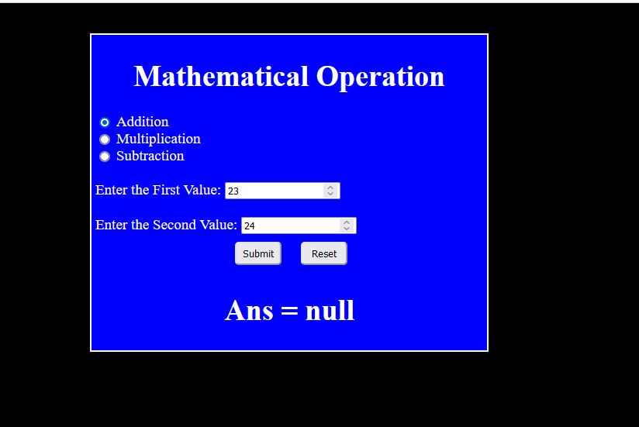Output **:-**

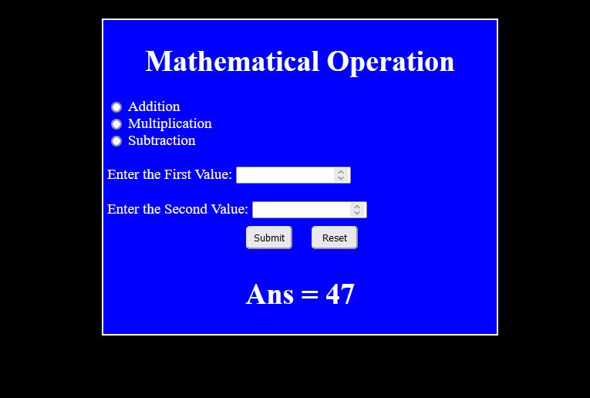

**Learning outcomes (What I have learnt):**

1. Learn About the servlet
2. Learn about jsp and dynamic web project
3. Learn about the tomcat server and its integrations with the java.